
Eeeeee

SafeRoute AI: Intelligent Road Hazard Detection and Accident Prevention System Industry Context

SCENARIO-BASED REQUIREMENT ANALYSIS
Submitted in the Partial fulfilment for the course of
CSA1012- SOFTWARE ENGINEERING
To the award of the degree of
BACHELOR OF ENGINEERING
IN
ARTIFICIAL INTELLIGENCE AND MACHINE LEARNING
Submitted by
P.TEJASWINI(192525171)

Under the Supervision of
Dr. K. ANITA DAVAMANI

SIMATS ENGINEERING
Saveetha Institute of Medical and Technical Sciences
Chennai-602105
Abstract
Road traffic accidents caused by unpredictable road hazards—such as potholes, fallen debris, waterlogging, and damaged road signage—represent a major challenge to global transportation safety. Traditional navigation applications prioritize travel time and route optimization over real-time hazard detection, while manual hazard reporting systems suffer from significant delays. This paper presents the Software Requirement Specification (SRS) for SafeRoute AI, an intelligent, scenario-based road hazard detection and accident prevention system. SafeRoute AI integrates computer vision, IoT edge sensors, GPS tracking, and spatial predictive analytics to monitor road conditions continuously. The platform captures visual road data, identifies hazards in real time, issues sub-second proximity warnings to drivers, and dynamically suggests safe alternative routes. Concurrently, it aggregates verified hazard data into a centralized Geographic Information System (GIS) dashboard, enabling transportation authorities to prioritize road maintenance and emergency response teams to receive automated incident logs. By establishing direct links between real-time edge processing and municipal infrastructure, SafeRoute AI provides a scalable, proactive safety framework designed to significantly reduce traffic accidents and enhance smart city transportation systems.

Introduction
Road safety is a critical global priority, with traffic accidents causing severe economic losses, injuries, and fatalities each year. A significant portion of these accidents is directly attributable to unmonitored road hazards—such as potholes, fallen debris, severe waterlogging, and damaged signage—which drivers encounter with little to no prior warning. Conventional navigation systems focus predominantly on calculating the fastest routes based on traffic density rather than evaluating physical road surface safety. Furthermore, traditional road hazard reporting heavily relies on slow, manual feedback loops from drivers or periodic manual inspections by transportation authorities, delaying both immediate warnings and necessary infrastructure repairs.
To address these challenges, SafeRoute AI is proposed as an intelligent, automated road hazard detection and accident prevention system. By combining computer vision, IoT vehicle sensors, GPS location tracking, and AI-driven predictive analytics, SafeRoute AI continuously monitors road conditions in real time. The system detects hazards from vehicle video streams, issues instant localized alerts to nearby drivers, suggests safe alternative routes, and logs detailed spatial data into a centralized dashboard for municipal maintenance and emergency response teams.

Problem Description
Drivers frequently face dangerous road surface defects without timely notifications, leading to sudden evasive maneuvers, vehicle damage, and collisions. Road authorities lack centralized, real-time spatial data to identify deteriorating road conditions and prioritize repair operations efficiently. Existing software solutions fail to bridge the gap between real-time driver alert systems and municipal maintenance management.

Scope of the System
- Vehicle Edge Detection: Ingests live video feeds from dashcams and IoT sensors to perform real-time optical recognition of road defects.
- Driver Navigation Support: Delivers sub-second proximity alerts and dynamic safe rerouting options to drivers heading toward identified hazard zones.
- Municipal Safety Dashboard: Maintains a centralized GIS database that generates hazard heatmaps, accident blackspot predictions, and automated maintenance work orders for road authorities.
- Emergency Integration: Directs automated incident notifications and location logs to emergency response services during severe disruptions.

1. Study and Scenario Analysis
1.1 Business Domain
Intelligent Transportation Systems (ITS), AI-driven Automotive Safety, Smart City Infrastructure, and Public Safety Management.

1.2 Key Stakeholders
- Drivers / Commuters: Primary end-users receiving safety alerts, optimized safe routes, and real-time hazard warnings.
- Transportation & Road Authorities: Municipal bodies and highway management teams utilizing hazard analytics to prioritize maintenance.
- Emergency Response Units: Traffic police, ambulance, and rescue services relying on accurate location mapping for emergency dispatch.
- System Administrators & AI Engineers: Personnel responsible for maintaining platform infrastructure, managing IoT feeds, and training vision models.

1.3 Existing Challenges
- Navigational App Limitations: Existing GPS applications focus on speed and distance optimization rather than physical road safety and real-time hazard detection.
- Manual Reporting Delay: Current hazard reporting relies on user inputs or post-incident reports, creating severe delays in driver notifications.
- Maintenance Inefficiencies: Road authorities lack centralized, prioritized data to efficiently direct repair operations to high-risk zones.

1.4 System Objectives
- Automatically detect potholes, debris, waterlogging, and damaged signage using AI computer vision.
- Provide sub-second real-time warnings and dynamic safe rerouting to drivers.
- Consolidate hazard data onto a centralized GIS mapping platform for authorities.
- Leverage predictive analytics to identify accident-prone blackspots using spatial and historical data.

2. System Requirements

2.1 Functional Requirements (FR)
Requirement ID | Module / Feature | Description
FR-01 | Visual Hazard Detection | The system shall analyze dashcam/camera video feeds using AI models to detect potholes, fallen debris, waterlogging, and damaged road signs in real time.
FR-02 | Geolocation Tagging | The system shall auto-capture and map exact GPS coordinates ($latitude,longitude$) whenever a road hazard is detected.
FR-03 | Driver Proximity Alerts | The system shall issue visual and auditory alerts to surrounding drivers when they approach a detected hazard within a configurable radius (e.g., $200\text{ meters}$).
FR-04 | Dynamic Rerouting | The system shall suggest safe alternative routes to drivers upon detecting severe road hazards or traffic disruptions ahead.
FR-05 | Accident Blackspot Prediction | The system shall utilize predictive analytics to flag potential high-risk zones using combined historical accident and road condition data.
FR-06 | Authority Dashboard | The system shall provide transportation authorities with a web portal displaying prioritized maintenance tickets, hazard heatmaps, and report generation tools.
FR-07 | Automated Emergency Notification | The system shall auto-dispatch critical alert notifications to emergency response teams in the event of major hazards or accidents.

2.2 Non-Functional Requirements (NFR)
- Performance:
- Latency: Critical driver alerts must be delivered in under $1\text{ second}$from hazard detection.
- Frame Processing: On-device/edge AI modules must process video feeds at a minimum of $30\text{ frames per second (FPS)}$.
- Security:
  - Data Protection: End-to-end encryption ($AES\text{-}256$) for all sensor transmission and user location telemetry.
  - Privacy: Automatic blurring/anonymization of vehicle license plates and pedestrian faces recorded in video feeds.
- Reliability & Availability:
  - Uptime: Platform cloud backend must maintain $99.9\%$operational availability.
  - Fault Tolerance: Local offline caching on mobile devices to preserve core navigation functions during cellular network outages.
- Scalability:
  - Architecture must scale horizontally to handle concurrent streaming feeds from $100,000+$connected vehicle edge devices.
- Usability:
  - Hands-free voice notifications and high-contrast UI tailored for minimal driver distraction.

3. Actors and Use Case Modeling
3.1 Primary and Secondary Actors
Primary Actors
- Vehicle Driver: Uses the application for navigation, receives hazard warnings, and streams camera/IoT sensor data.
- Transportation Authority Admin: Accesses the portal to review road analytics, inspect verified hazards, and assign maintenance work orders.
Secondary Actors
- Emergency Responders: Receive auto-generated location logs during severe incidents.
- Edge/IoT Camera Unit: Hardware module capturing, preprocessing, and transmitting road visual data.
- AI Computer Vision Core: Automated subsystem running object detection algorithms on video streams.

3.2 List of Use Cases
- UC-01: Stream Road Video & Sensor Telemetry (Actor: Edge/IoT Camera Unit)
- UC-02: Process Image & Detect Road Hazards (Actor: AI Computer Vision Core)
- UC-03: Receive Real-time Hazard Alert (Actor: Vehicle Driver)
- UC-04: View Safe Alternative Route (Actor: Vehicle Driver)
- UC-05: View Road Hazard Heatmap & Analytics (Actor: Transportation Authority Admin)
- UC-06: Generate Road Maintenance Work Orders (Actor: Transportation Authority Admin)
- UC-07: Dispatch Emergency Services (Actor: Emergency Responders)

3.3 Use Case Diagram
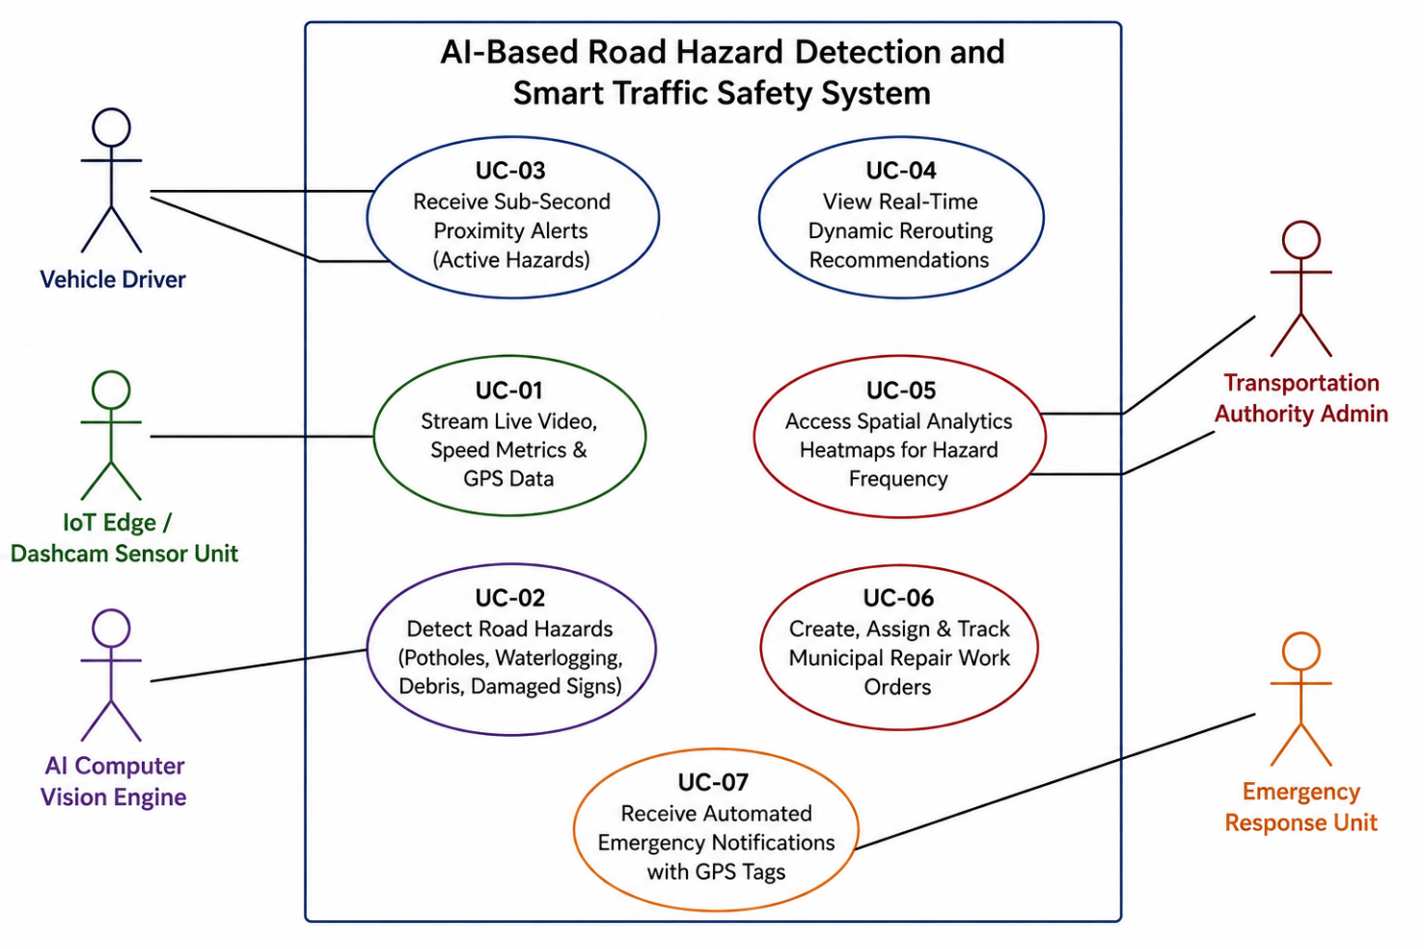

4. Software Requirement Specification Details
4.1 System Scope
SafeRoute AI integrates computer vision, IoT telemetry, and cloud GIS analytics to proactively prevent accidents. It spans edge detection on vehicles, immediate driver warning systems, dynamic navigational alterations, and administrative maintenance coordination.

4.2 Use Case Descriptions
Use Case UC-03: Receive Real-Time Hazard Alert
- Primary Actor: Vehicle Driver
- Preconditions: Driver has the application active, GPS signal is established, and vehicle is within proximity of a flagged hazard.
- Main Success Scenario:
  - System detects vehicle trajectory heading toward a verified hazard zone within $200\text{ meters}$.
  - System calculates distance and required braking/deceleration response time.
  - System issues visual banner and voice prompt: "Caution: Severe Pothole detected 150 meters ahead."
  - Driver acknowledges warning or adjusts vehicle speed safely.
- Postconditions: Driver successfully navigates around hazard; interaction logged for analytics.
- Alternative Flow: If cellular data drops, system utilizes cached local spatial data to fire offline proximity alerts.
Use Case UC-06: Generate Road Maintenance Work Orders
- Primary Actor: Transportation Authority Admin
- Preconditions: Admin is authenticated on the web portal; multiple hazard detections are aggregated for a specific road section.
- Main Success Scenario:
  - Admin navigates to the Hazard Severity Heatmap panel.
  - System ranks road sections by hazard frequency and severity scores.
  - Admin selects a high-density hazard region (e.g., severe road damage).
  - Admin clicks Generate Work Order, populating exact GPS tags, visual proof images, and road identifiers.
  - Work order is dispatched to local field repair teams.
- Postconditions: Work order status set to "Pending Repair" on the system dashboard.

4.3 Data Requirements
Data Entity | Key Attributes
Hazard Tag | Hazard_ID (Primary Key), Hazard_Type (Pothole, Debris, Flooding, Damaged Signage), GPS_Latitude, GPS_Longitude, Severity_Score (1–5), Timestamp, Image_URI, Verification_Status
Telemetry Log | Telemetry_ID (Primary Key), Device_ID (ForeignKey),Vehicle_Speed, Heading_Direction, GPS_Latitude, GPS_Longitude, Captured_At
Maintenance Work Order | Work_Order_ID (Primary Key), Hazard_ID (Foreign Key), Assigned_Department, Priority_Level, Repair_Status (Open, In-Progress, Resolved), Created_Date, Target_Completion_Date
Driver Account | User_ID (Primary Key), Full_Name, Device_Token, Notification_Preferences, Registration_Date
Emergency Incident | Incident_ID (Primary Key), Hazard_ID (Foreign Key), GPS_Location, Alert_Timestamp, Dispatch_Status, Assigned_Unit_ID

4.4 External Interface Requirements
- User Interfaces:
  - Mobile UI: Minimalist driver interface optimized for mounting on vehicle dashboards.
  - Web Admin Dashboard: GIS map integration with layer toggles (Heatmaps, Active Crews, Historical Blackspots).
- Hardware Interfaces: Standard interfaces to vehicle dashcams ($USB/WiFi/CAN\text{-}bus$) and external IoT sensor modules (accelerometers/gyroscopes).
- Software & API Interfaces:
  - Integration with mapping services (Google Maps API / OpenStreetMap) for baseline routing data.
  - REST API / WebSockets endpoints for real-time streaming telemetry and notifications.
5. Assumptions and Constraints
5.1 Assumptions
- Mobile devices or edge hardware have active access to functional GPS receivers with clear line-of-sight to satellites.
- Dashcams maintain adequate lens clarity and stable mounting during vehicle motion.
- Transportation authorities maintain digital infrastructure capable of receiving automated work order tickets.

5.2 Project Constraints
- Technical Constraints: Computer vision inference models on edge devices must operate under strict hardware memory constraints ($≤2\text{ GB RAM}$ allocation).
- Operational Constraints: AI hazard detection accuracy may degrade under extreme environmental conditions (e.g., heavy fog, torrential rain at night).
- Legal & Regulatory Constraints: Absolute compliance with regional data privacy laws (e.g., GDPR, local traffic recording privacy mandates). All video recordings must be processed locally or stripped of personally identifiable information (PII) prior to cloud upload.
- Time Constraints: Core functional prototype must be completed within the allocated academic assessment schedule.

6. Requirement Validation and Consistency Analysis
6.1 Validation Check
- Completeness: Evaluated against all 8 project objectives specified in Problem Statement 32. All aspects—from continuous IoT video ingestion to municipal reporting—are mapped directly to functional requirements (FR-01 through FR-07).
- Consistency: Confirmed that latency bounds ($≤1\text{ second}$) defined in Non-Functional Requirements directly support real-time driver proximity alerts (FR-03).
- Ambiguity Reduction: Quantified threshold definitions across functional criteria (e.g., replaced "alert driver early" with "alert driver within a $200\text{-meter}$configurable radius").

6.2 Suggested Enhancements
- Crowdsourced Verification Loop: Implement a quick-feedback voice response mechanism (e.g., "Is hazard still there?" -> "Yes/No") to reduce false positives and purge cleared hazards from the database.
- Edge AI Model Optimization: Introduce lightweight quantized neural architectures (e.g., YOLOv8-Nano / MobileNetV4) to ensure high FPS detection on low-cost dashcam hardware without overheating.

7.External Interface Requirements
- User Interfaces (UI)
  - Driver Mobile Interface: Minimalist dashboard optimized for hands-free driving with high-contrast alert popups, real-time map views, and visual/audio navigation overlays.
  - Authority Web Portal: Responsive GIS-based web application featuring interactive heatmaps, filterable hazard logs, and work-order management panels.
- Hardware Interfaces
  - Dashcam & Video Units: USB/Wi-Fi/Bluetooth connections to capture continuous real-time dashcam optical feeds ($1080\text{p}$ at $≥30\text{ FPS}$).
  - Vehicle IoT Sensors: Interface with vehicle accelerometers, gyroscopes, and CAN-bus units to detect sudden impacts or severe road vibrations.
- Software Interfaces
  - Mapping & GIS APIs: Integration with Google Maps API, Mapbox, or OpenStreetMap for routing, map rendering, and reverse geocoding.
  - Database & Cloud Platform: Direct connection to cloud spatial databases (e.g., PostgreSQL with PostGIS, AWS RDS) for synchronized data logging.
- Communication Interfaces
  - Networking Protocols: HTTPS/RESTful APIs for general application requests and WebSockets/MQTT for low-latency, real-time telemetry streaming and hazard broadcasts.
  - Push Notification Services: Firebase Cloud Messaging (FCM) or Apple Push Notification service (APNs) for instant driver hazard alerts.

8.System Features
- Real-Time Automated Hazard Detection
  - Processes continuous video feeds from vehicle dashcams using AI computer vision to identify potholes, road debris, flooding, and damaged signs.
  - Auto-tags detected hazards with precise GPS coordinates ($latitude,longitude$) and timestamp data.
- Sub-Second Proximity Driver Alerting
  - Calculates vehicle distance to active hazard zones and issues visual/audio warnings within a $200\text{-meter}$ proximity.
  - Delivers low-latency alerts via WebSockets/MQTT protocols in under $1\text{ second}$.
- Dynamic Safe Route Recommendation
  - Analyzes ahead-of-path hazards and automatically generates real-time alternative safe routes.
  - Integrates with mapping APIs (Google Maps/Mapbox) to bypass severe disruptions.
- Accident Blackspot Predictive Analytics
  - Evaluates historical accident data combined with current road condition metrics to map high-risk zones.
  - Generates spatial heatmaps identifying emerging accident-prone locations.
- Authority Maintenance Management Portal
  - Provides a centralized web-based GIS dashboard for transportation authorities.
  - Auto-generates prioritized road maintenance work orders with visual evidence and exact locations to streamline repairs.
- Automated Emergency Incident Dispatch
  - Triggers immediate emergency alert notifications with GPS coordinates to responders during severe incidents or major road blockages.

9.Requirement Validation
- Stakeholder Coverage: All primary and secondary stakeholder requirements—including real-time driver warnings, authority maintenance dispatch, and emergency notification loops—have been fully mapped to explicit functional specifications.
- Consistency & Feasibility Analysis: Non-functional latency bounds ($≤1\text{ second}$) directly align with real-time hazard detection needs, ensuring zero operational conflicts between edge vision processing and push alert triggers.
- Quality Enhancements: To eliminate ambiguity and redundancy, hazard tagging relies on standardized geospatial data schemas ($latitude,longitude$), and edge computer vision inference is constrained to quantized models to guarantee stable performance on standard dashcam hardware.

10.Conclusion
The SafeRoute AI platform successfully bridges the gap between proactive driver safety and municipal road maintenance. By replacing manual hazard reporting with real-time AI computer vision and IoT sensor analysis, the system delivers immediate proximity warnings and safe rerouting to drivers while equipping road authorities with actionable, prioritized maintenance data. This dual approach mitigates vehicle damage, prevents accidents, and provides a scalable, intelligent framework for modern smart city transportation infrastructure.

